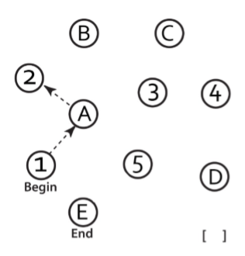 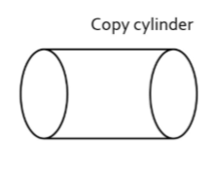

[ ] [ ]

**In the space below, draw a clock with the hands at ten past nine.**

**Name the animals in the pictures below.**

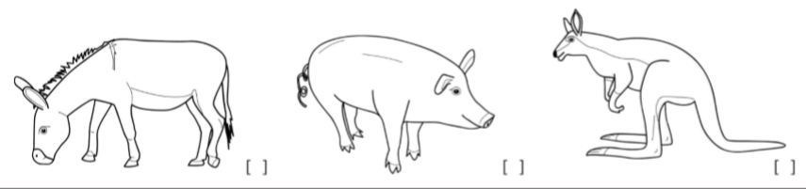

[ ] [ ] [ ]

**Have subject repeat the following words. Do two trials.**

**TRAIN** [ ] [ ] **EGG** [ ] [ ] **HAT** [ ] [ ] **CHAIR** [ ] [ ] **BLUE** [ ] [ ]

**Read the following lists of digits:**

1. Repeat the following in the forward order: **5, 4, 1, 8, 7**  [ ]
2. Repeat the following in the backward order: **1, 7, 4** [ ]

**Read the list of letters. Subject has to tap their hand each time they hear the letter “A”:**

* F B A C M N A A J K L B A F A K D E A A A J A M O F A A B [ ]

**Starting at 80, have subject count back by 7’s:**

* 73 [ ] 66 [ ] 59 [ ] 52[ ] 45 [ ]

**Have subject repeat the following:**

* She heard his lawyer was the one to sue after the accident. [ ]
* The little girls who were given too much candy got stomach aches. [ ]

**Have subjects name as many words as they can in one minute that start with the letter B:**

* [ ] _____ (N >= 11 words)

**Have subjects describe similarity between the following objects:**

* Eye – Ear [ ] Trumpet – Piano [ ]

**Delayed Recall:**

* **TRAIN** [ ]  **EGG** [ ] **HAT** [ ] **CHAIR** [ ] **BLUE** [ ]

**Orientation:**

* **Date** [ ] **Month** [ ] **Year** [ ] **Day** [ ] **Place** [ ] **City** [ ]